
NORTHERN LIGHTS COLLEGE EDUCATION COUNCIL
Meeting to be held October 27 2026 at 1:15pm
Chetwynd – Microsoft Teams
Dawson Creek – Microsoft Teams or Regional Boardroom
Fort St John – Microsoft Teams or Room 1810
AGENDA
Territorial Acknowledgement:
Northern Lights College acknowledges that our campuses are situated on the ancestral and traditional land of many nations, including the Dane Zaa, Cree, Tsáá? Ché Ne Dane, Saulteau, Tse’Khene, Kaska Dena, Tahltan, and Tlingit. We also recognize Metis Nation members who share a deep history with this land.
We, at Northern Lights College, commit to restoring and honouring the Truth and Reconciliation calls to action; we strongly believe that truth must be acknowledged to move forward to reconciliation. We are grateful for the Traditional Knowledge Keepers and Elders who are still with us today and those who have gone before us. We acknowledge our hosts and honor their gracious welcome to those seeking knowledge.
- Adoption of Agenda B. Mackinnon

- Adoption of Minutes: September 22, 2026 B. Mackinnon
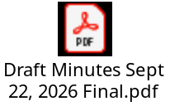
- Action List Review B. Mackinnon


Decision Items
Education Council exclusive authority:
- Electrician Foundation Trades Training J. Klassen
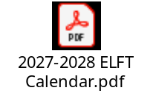
Motions
- THAT Education Council approves the revised Program Information and Completion Guide for Electrician Foundation Trades and the new Course Outline ELFT 103, effective September 2027.
- THAT Education Council approves the deactivation of the ELFT 102 and ELFT 101 courses, effective September 2027.

- DRAFT Policy Student Representative Remuneration, K. Bravo
DRAFT Procedures Student Representative Remuneration and
DRAFT Student Representative TOR
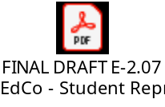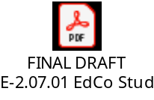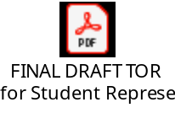
Motion
THAT Education Council approves the revised Policy E-2.07 Education Council – Student Representative Remuneration, the new Student Representative Remunerations Procedures and the A-5.02.25 Education Council Student Representative TOR, effective October 27, 2026.

Standing Reports
- Vice-President Academics & Research T. Hyland-Russell

- Board of Governors M. Waldorf

- Education Council Chair B. Mackinnon
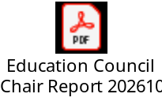
- Educational Policies Committee K. Bravo

- Curriculum Committee R. Douglas

- Admissions and Standards Committee A. Holloway

Next Meeting – November 24, 2026
Adjournment

