
NORTHERN LIGHTS COLLEGE EDUCATION COUNCIL
Meeting to be held September 22, 2026 at 1:15pm
Dawson Creek – Microsoft Teams or Regional Boardroom
Fort St John – Microsoft Teams or Room 1810
AGENDA
Territorial Acknowledgement:
Northern Lights College acknowledges that our campuses are situated on the ancestral and traditional land of many nations, including the Dane Zaa, Cree, Tsáá? Ché Ne Dane, Saulteau, Tse’Khene, Kaska Dena, Tahltan, and Tlingit. We also recognize Metis Nation members who share a deep history with this land.
We, at Northern Lights College, commit to restoring and honouring the Truth and Reconciliation calls to action; we strongly believe that truth must be acknowledged to move forward to reconciliation. We are grateful for the Traditional Knowledge Keepers and Elders who are still with us today and those who have gone before us. We acknowledge our hosts and honor their gracious welcome to those seeking knowledge.
- Adoption of Agenda B. Mackinnon

- Adoption of Minutes: June 24, 2026 and June 29, 2026 B. Mackinnon
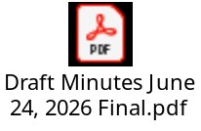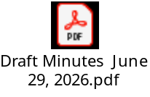
- Action List Review B. Mackinnon
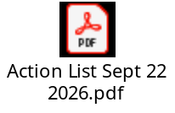

Decision Items
Education Council joint approval with Board of Governors:
- Community Development Worker Diploma C. DiPietro
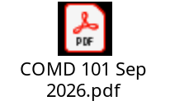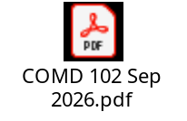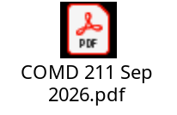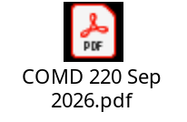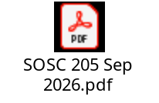
Motions:
- THAT the Education Council approves the Program Information and Completion Guide for the Community Development Worker Diploma and recommends to the Board of Governors that this credential be established, effective September 2027.
- THAT the Education Council approves the new Course Outlines for COMD 101, COMD 102, ECON 205, COMD 211, SOSC 205, POLI 206 and COMD 220, and recommends to the Board of Governors that these courses be established, effective September 2027.
Education Council exclusive authority:
- Practical Nursing and Access to Practical Nursing D. Stavrou
*please see D2L for submission documents
Motions:
- THAT the Education Council approves the revised Course Outlines APNP 130, APNP 131, APNP 132, APNP 133, APNP 134, APNP 135, APNP 136, PNUR 110, PNUR 111, PNUR 112, PNUR 113, PNUR 114, PNUR 115, PNUR 116, PNUR 120, PNUR 121, PNUR 122, PNUR 123, PNUR 124, PNUR 125, PNUR 126, PNUR 230, PNUR 231, PNUR 232, PNUR 233, PNUR 235, PNUR 236, PNUR 242, PNUR 243, PNUR 245, PNUR 246, PNUR 248, effective September 2027.
- THAT the Education Council approves the revised Program Guides for APN and PNUR, effective September 2027.
- THAT the Education Council approves the deactivation of the PNUR 240, PNUR 241 and PNUR 247 courses, effective September 2027.

Standing Reports
- Vice-President Academics & Research T. Hyland-Russell
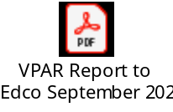
- Board of Governors M. Waldorf

- Education Council Chair B. Mackinnon

- Educational Policies Committee K. Bravo

- Curriculum Committee R. Douglas

- Admissions and Standards Committee K. Bravo

Discussion/Information Items
- Office Administration certificates K. Bravo
*Correction of Course Numbers:
OADM 114 -> OADM 118
OADM 135 -> OADM 126
OADM 136 -> OADM 127
OADM 154 -> OADM 151
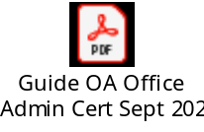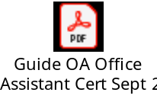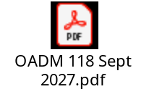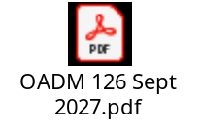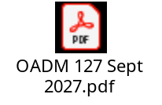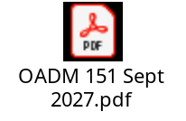

Next Meeting – October 27, 2026
Adjournment

